public function actionIndex()

{

{

$blogPost = new BlogPost();

$blogPost->title = 'Gotcha!';

$blogPost->text = 'We need some laughter to ease the tension of holiday shopping . ' ;

$blogPost->save();

return $this->renderContent(Html::tag('pre',

VarDumper::dumpAsString($blogPost->attributes)

));

}

}

1. That is it. Now, run test/index. You should get the following result:

How it works...

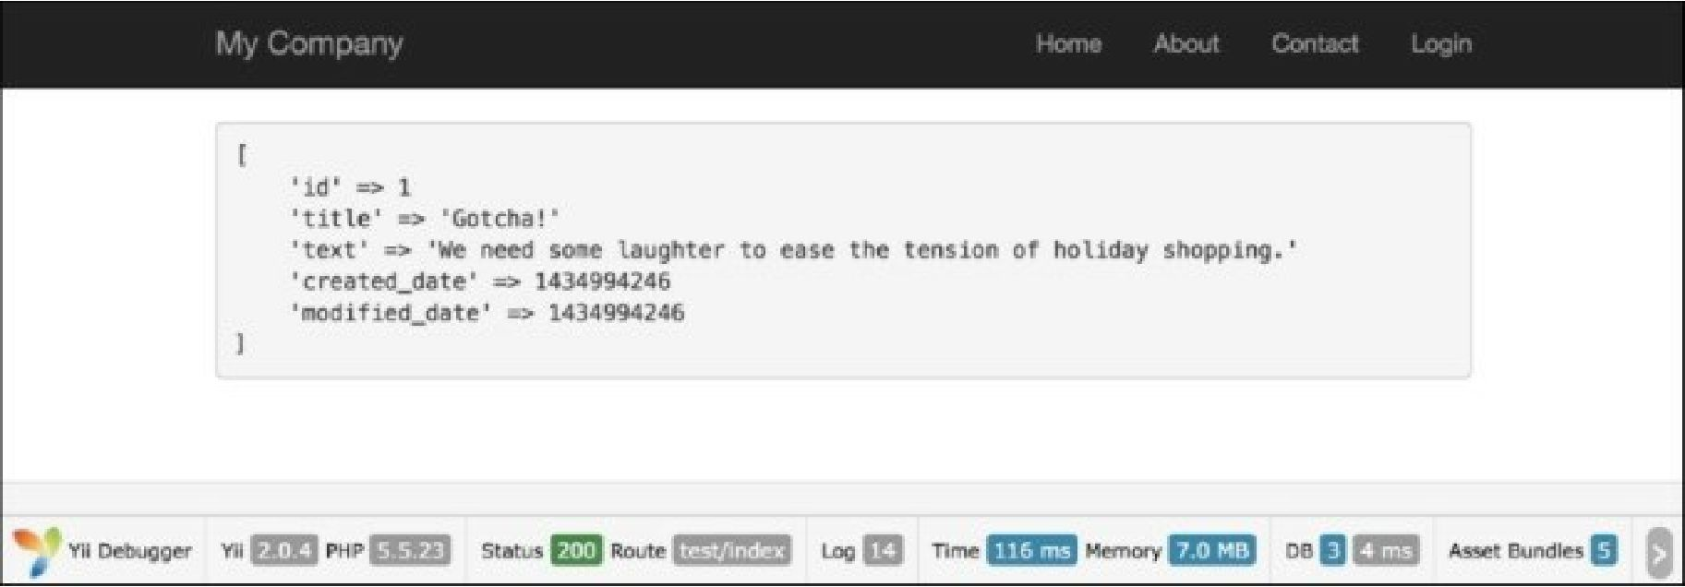

By default, the Timestamp behavior populates created_at (the timestamp which points to the time when the model was created) and updated_at (the time when the model was updated). It’s a standard practice to name these fields, but if we would like to make a change, we can specify fields, which will be updated, and model events.

There’s more.

For instance, our fields are named creation_date and modified_date.

Let’s configure our model with behavior according to these fields. In addition, we should add our behavior’s code to our Post model:

<?php

namespace app\models; use Yii;

use yii\db\BaseActiveRecord;